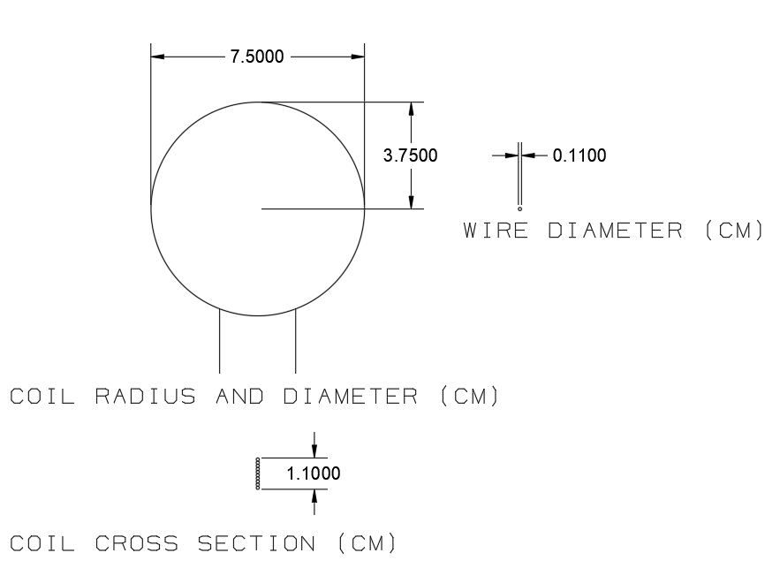
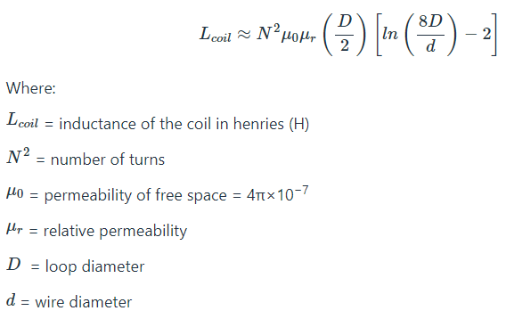

Final Inductance = 50.469 uH

Frequency(Hz) | Inductive Reactance (Ohms) | Angular Freq (rad/s)
1 | 0.00031711 | 6.283
10 | 0.003171 | 62.832
100 | 0.03171061 | 628.319
1000 | 0.31710608 | 6283.185
10000 | 3.17106 | 62831.853
100000 | 31.71061 | 628318.531
1000000 | 317.10608 | 6.283 × 10+6
10000000 | 3171.06 | 6.283 × 10+7

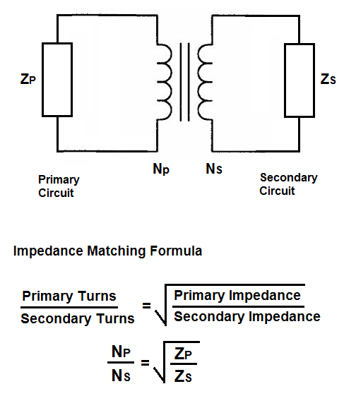

Frequency(Hz) | Turn Ratio | Secondary Turns, Ns ( Assuming 10 primary turns )
1 | 397.082 : 1 | 0.025
10 | 125.57 : 1 | 0.079
100 | 39.709 : 1 | 0.251
1000 | 12.557 : 1 | 1
10000 | 3.971 : 1 | 3
100000 | 1.256 : 1 | 8
1000000 | 1 : 2.518 | 25
10000000 | 1 : 7.964 | 80

